ZEN CLASS MONGODB QUERIES- TASK 2

Q1:Find all the mentors with who has the mentee's count more than 15

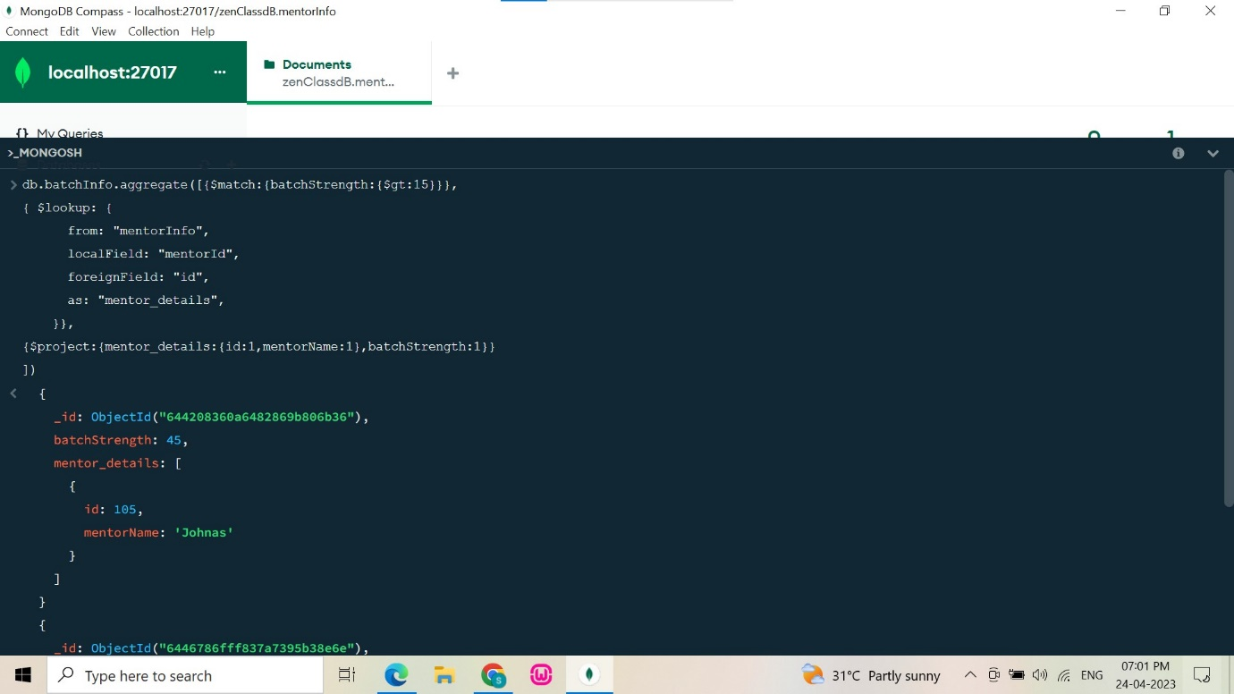

Q2:Find the number of problems solved by the user in codekata

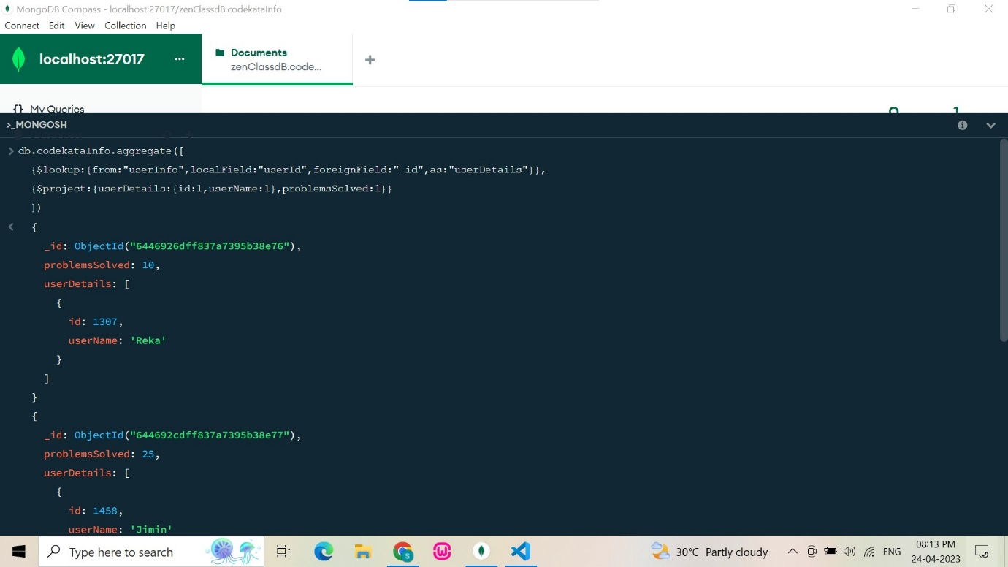

Q3:Find all the topics and tasks which are thought in the month of October

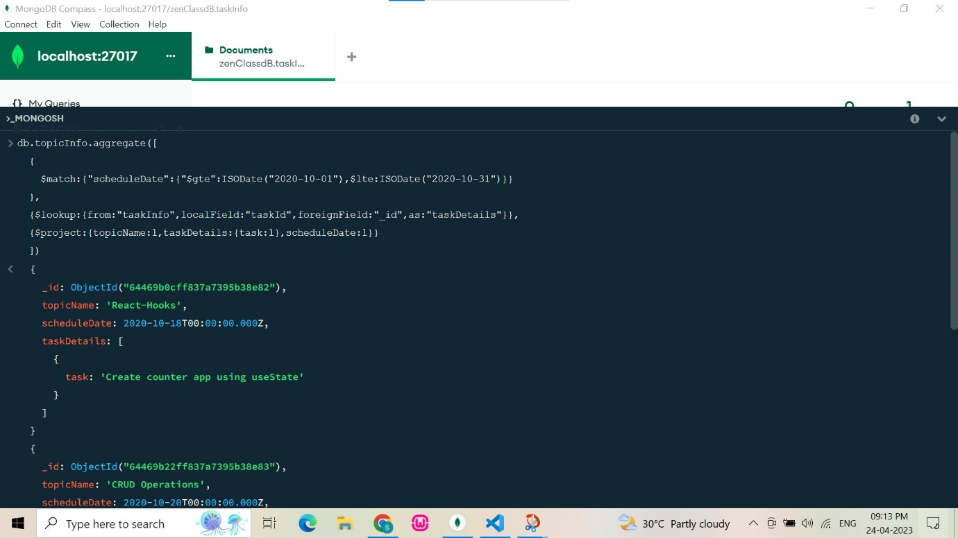

Q4:Find all the company drives which appeared between 15 oct-2022 and 31-oct-2022

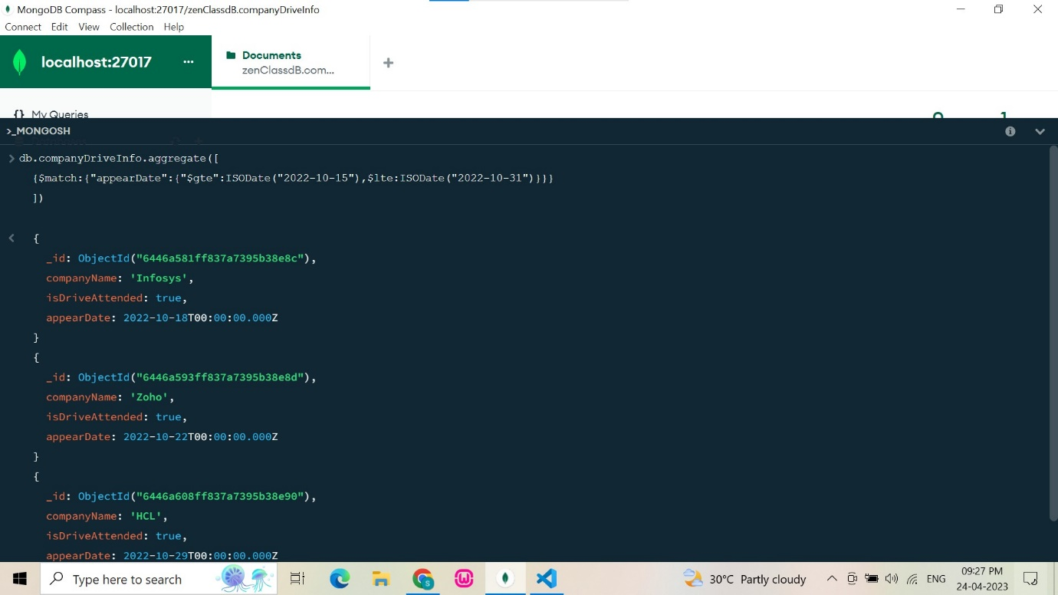

Q5:Find the number of users who are absent and task is not submitted between 15 oct-2020 and 31-oct-2020

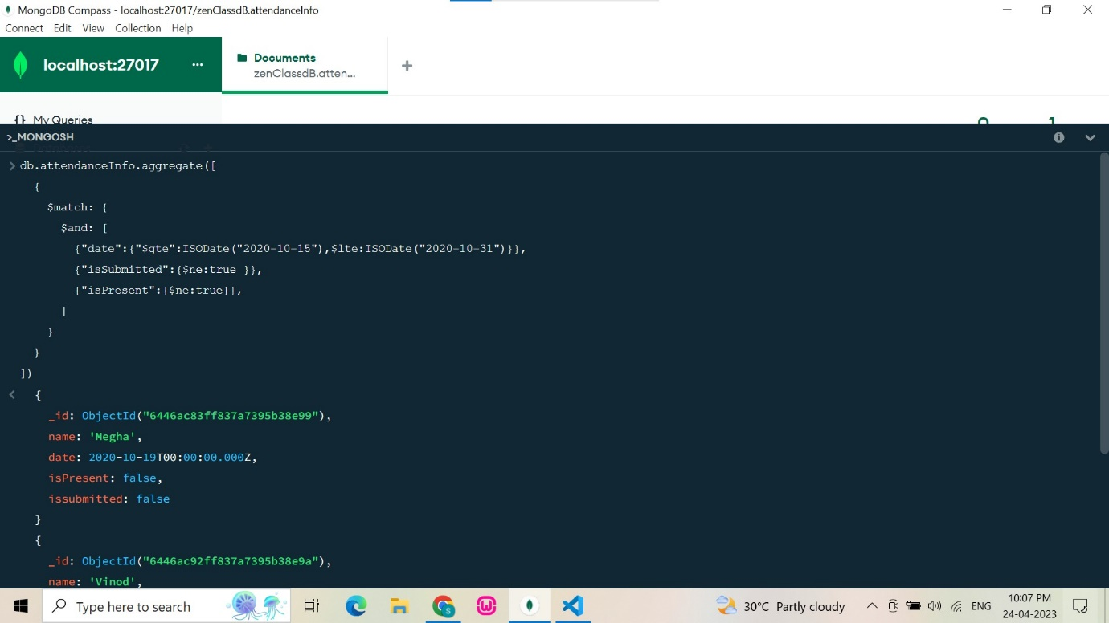

Q6:Find all the company drives and students who are appeared for the placement.

